TASK 1:
1.
Install Jupyter notebook and run your first program and share screenshot of the output
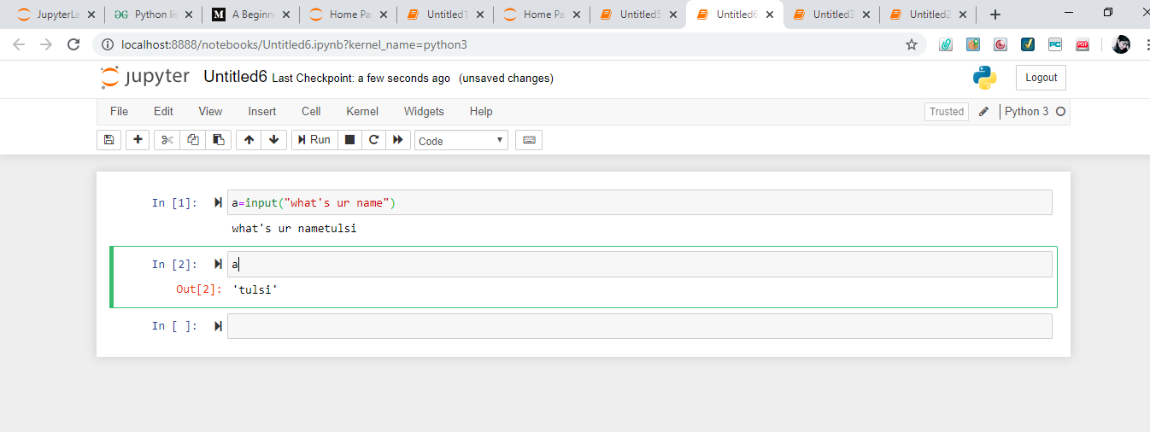
2.
Write a program which will find such numbers which are divided by 7 but are not a multiple of 5,between 2000 and 3200(both included).the numbers obtain should printed in comma separated sequence on a single line. 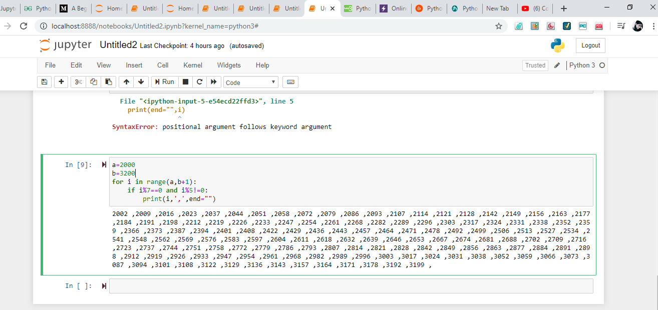
3.
Write a python program to accept the user’s first and last name and then getting them printed in the reverse order with the space between firdt name and last name.
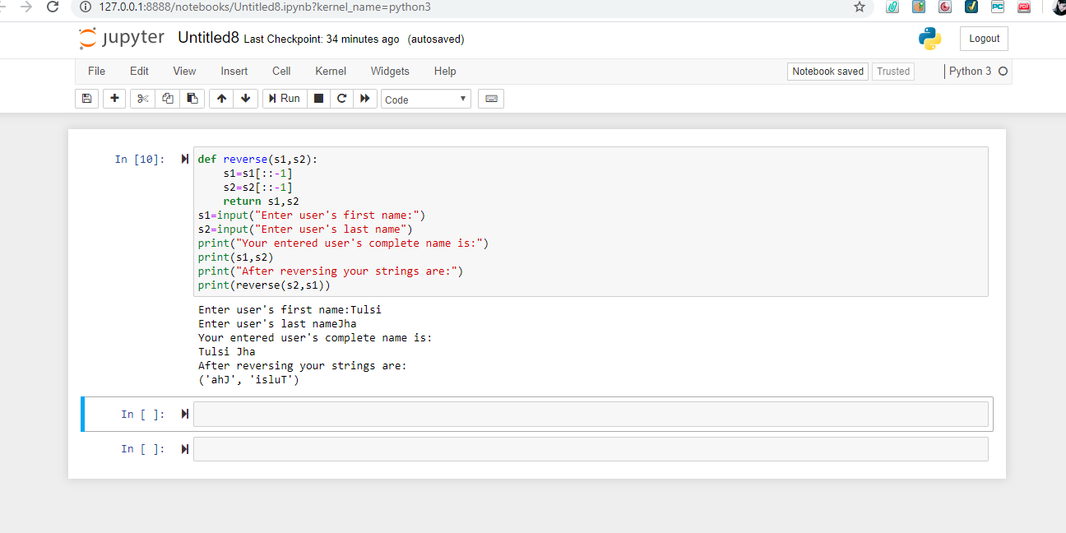
4.
Write a python program to the volume of sphere with diameter 12cm
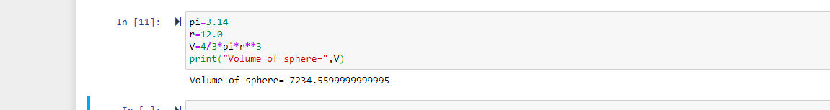

TASK 2:
1.
Write a program which accept a sequence of comma-separated s from console and generate a list.
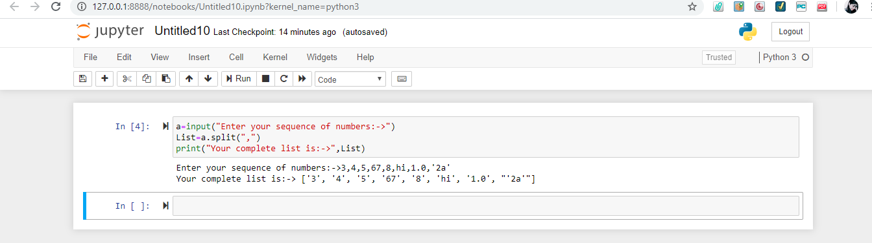

2.
Create a below pattern using tested for loop in Python

*
* *
* * *
* * * *
* * * * *
* * * *
* * *
* *
*
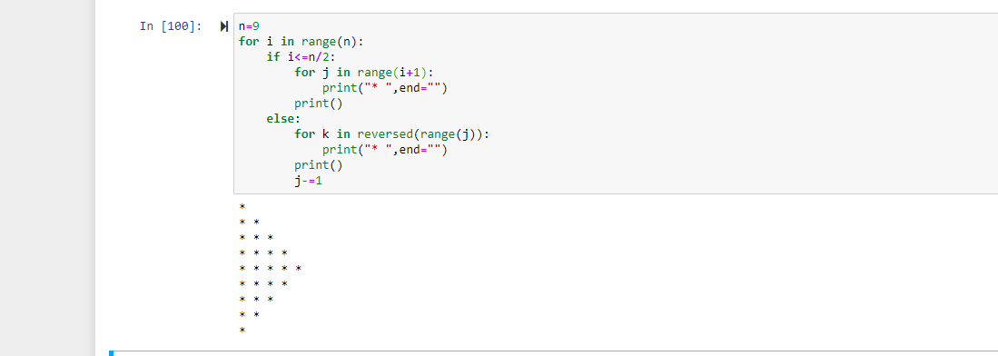
3.
Write a python program to reverse the word after accepting the input from the user.
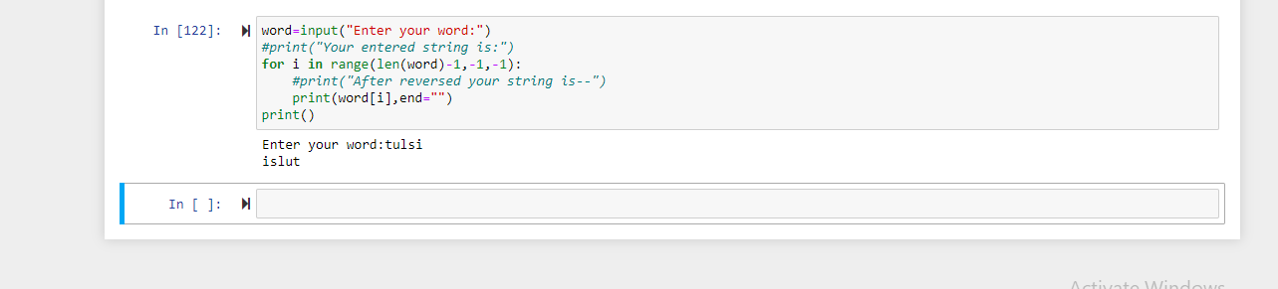
4.
Write the Python program to print the given string in format specified.
